A

(Accredited by NAAC, NBA, Permanently Affiliated to JNTUH, Approved by AICTE, New Delhi) Recognized Under Section 2(f) & 12(B) of the UGC Act.1956, Kandlakoya (V), Medchal Road,

Hyderabad-501401.

**2019-2023**

**UGC AUTONOMOUS**

**CMR TECHNICAL CAMPUS**

**DEPARTMENT OF COMPUTER SCIENCE AND ENGINEERING**

(Assistant Professor)



**NAJEEMA AFRIN**

Under the Guidance of

ANANYA CHOWDARY BHEEMANENI (197R1A05J6)

SAI PRANAV GUNTHA (197R1A05L4)

SUMANTH CH (197R1A05K1)

By

In

COMPUTER SCIENCE AND ENGINEERING

BACHELOR OF TECHNOLOGY

(Submitted in partial fulfillment of the requirements for the award of Degree)

**CHATBOT FOR PREGNANT WOMEN**

On

Major Project

**DEPARTMENT OF COMPUTER SCIENCE AND ENGINEERING**



**CERTIFICATE**

This is to certify that the project entitled **“CHATBOT FOR PREGNANT WOMEN”** being submitted by **ANANYA CHOWDARY BHEEMANENI (197R1A05J6), SAI PRANAV GUNTHA (197R1A05L4) & CH. SUMANTH (197R1A05K1)** in partial fulfillment of the requirements for the award of the degree of B.Tech in Computer Science and Engineering to the Jawaharlal Nehru Technological University Hyderabad, is a record of bonafide work carried out by them under our guidance and supervision during the year 2022-23.

The results embodied in this thesis have not been submitted to any other University or Institute for the award of any degree or diploma.

**Najeema Afrin**  **Dr. A. Raji Reddy**

(Assistant Professor) DIRECTOR

INTERNAL GUIDE

**Dr. K. Srujan Raju EXTERNAL EXAMINER**

#### HOD

**Submitted for viva voice Examination held on**

# ACKNOWLEDGEMENT

Apart from the efforts of us, the success of any project depends largely on the encouragement and guidelines of many others. We take this opportunity to express our gratitude to the people who have been instrumental in the successful completion of this project.

We take this opportunity to express my profound gratitude and deep regard to our guide **Najeema Afrin,** Assistant Professor for her exemplary guidance, monitoring and constant encouragement throughout the project work. The blessing, help and guidance given by her shall carry us a long way in the journey of life on which we are about to embark.

We also take this opportunity to express a deep sense of gratitude to the Project Review Committee (PRC) **Dr. Punyaban Patel, Ms. Shilpa, Dr.T . Subha Mastan Rao & J. Narasimharao** for their cordial support, valuable information and guidance, which helped us in completing this task through various stages.

We are also thankful to **Dr. K. Srujan Raju,** Head, Department of Computer Science and Engineering for providing encouragement and support for completing this project successfully.

We are obliged to **Dr. A. Raji Reddy,** Director for being cooperative throughout the course of this project. We also express our sincere gratitude to Sri. **Ch. Gopal Reddy,** Chairman for providing excellent infrastructure and a nice atmosphere throughout the course of this project.

The guidance and support received from all the members of **CMR Technical Campus** who contributed to the completion of the project. We are grateful for their constant support and help.

Finally, we would like to take this opportunity to thank our family for their constant encouragement, without which this assignment would not be completed. We sincerely acknowledge and thank all those who gave support directly and indirectly in the completion of this project.

**ANANYA CHOWDARY BHEEMANENI (197R1A05J6)**

**SAI PRANAV GUNTHA (197R1A05L4)**

**SUMANTH CH (197R1A05K1)**

**ABSTRACT**

Artificial intelligence is transforming healthcare with a profound paradigm shift impacting diagnostic techniques, drug discovery, health analytics, interventions and much more. In this paper we focus on exploiting AI-based chatbot systems, mainly based on machine learning algorithms and Natural Language Processing, to understand and respond to needs of patients and their families. In particular, we describe an application scenario for an AI-chatbot delivering support to pregnant women, mothers, and families with young children, by giving them help and instructions in relevant situations.

Medical services are basic needs for human life although they normally have limited resources.Modern technologies are utilized for increasing service capability and decreasing the operation cost. Auto-response system or chatbot, which is widely known in the field of online businesses, can be applied to the medical services.

Therefore, the objective of this work is to implement the medical consultant system service by using chatbot Technology. In this project we focus on exploiting AI-based chatbot systems, mainly based on machine learning algorithms and Natural Language Processing, to understand and respond to needs of patients and their families. In particular, we describe an application scenario for an AI-chatbot delivering support to pregnant women, mothers, and families with young children, by giving them help and instructions in relevant situations.

**i**

**LIST OF FIGURES/TABLES**

**FIGURE NO. FIGURE NAME PAGE NO**

Figure 4.1 Architecture of Chat-bot for pregnant women 9

Figure 4.2 Use Case Diagram for Chat-bot for pregnant 10

women

Figure 4.3 Class Diagram for Chat-bot for pregnant 11

women

Figure 4.4 Sequence Diagram for Chat-bot for pregnant 12

women

Figure 4.5 Activity Diagram for Chat-bot for pregnant 13

women

**ii**

**ii**

**LIST OF SCREENSHOTS**

**SCREENSHOT NO. SCREENSHOT NAME PAGE NO**

Screenshot 6.1 Final GUI of Chat-bot for Pregnant 21

women

Screenshot 6.2 Conversation of Chat-bot with Pregnant 22

women

**iii**

**TABLE OF CONTENTS**

**ABSTRACT i**

**LIST OF FIGURES ii**

**LIST OF SCREENSHOTS iii**

1. **INTRODUCTION** 1
   1. PROJECT SCOPE 1
   2. PROJECT PURPOSE 1
   3. PROJECT FEATURES 1
2. **LITERATURE SURVEY**  2
3. **SYSTEM ANALYSIS**  5

3.1 PROBLEM DEFINITION 5

3.2 EXISTING SYSTEM 5

3.2.1 DISADVANTAGES OF THE EXISTING SYSTEM 6

3.3 PROPOSED SYSTEM 6

3.3.1 ADVANTAGES OF PROPOSED SYSTEM 6

3.4 FEASIBILITY STUDY 7

3.4.1 ECONOMIC FEASIBILITY 7

3.4.2 TECHNICAL FEASIBILITY 8

2.4.3 SOCIAL FEASIBILITY 8

3.5 HARDWARE & SOFTWARE REQUIREMENTS 8

3.5.1 HARDWARE REQUIREMENTS 8

3.5.2 SOFTWARE REQUIREMENTS 8

**4. ARCHITECTURE** 9

4.1 PROJECT ARCHITECTURE 9

4.2 DESCRIPTION 9

4.3 USE CASE DIAGRAM 10

4.4 CLASS DIAGRAM 11

4.5 SEQUENCE DIAGRAM 12

4.6 ACTIVITY DIAGRAM 13

**5. IMPLEMENTATION** 14

5.1 SAMPLE CODE 14

**iv**

**6. RESULTS**  20

**7. TESTING**  **22**

7.1 INTRODUCTION TO TESTING 22

7.2 TYPES OF TESTING 22

7.2.1 UNIT TESTING 22

7.2.2 INTEGRATION TESTING 23

7.2.3 FUNCTIONAL TESTING 23

7.3 TEST CASES 24

**8. CONCLUSION & FUTURE SCOPE 25**

8.1 PROJECT CONCLUSION 25

8.2 FUTURE SCOPE 25

**9. BIBILIOGRPHY** **26**

9.1 REFERENCES 26

9.2 GITHUB LINK 26

**iv**

1. **INTRODUCTION**

CMRTC 1

CHATBOT FOR PREGNANT WOMEN

1. **INTRODUCTION**

Healthcare is one of the top three biggest mobile trends in US. In recent study shows that US adults who own smartphone or other wireless device, have at least one health/fitness app on their smartphone (+16% over the past two years) and, generally, health Apps have some of the highest number of downloads. Two-thirds of women said they would use a mobile App to manage health-related issues . Similar trends are expected for Europe.

Also for this reason, smart-phones and wearable devices are more and more equipped with sensors and Apps able to collect an amount of health and wellness data which is by far bigger than that provided in the past decades of medical-device development. Correspondingly, a plethora of free and premium medical apps have been developed, with a variety of purposes and usage (e.g. drug dosage, medicine recommendations, symptoms diagnoses, etc.).

This allows to connect patients with healthcare laboratories , increase adherence to health monitoring, treatment regimen and medication manage chronic diseases provide educational contents and prevent infectious and sexually-transmitted diseases.

The diffusion of mobile devices to support medical and public health practices, referred to as mHealth has, therefore, the potential to increase accessibility and to support shifts towards prevention by contributing to make access to healthcare more equitable, and this is supported by several indicators: in Europe, for example, up to 50% of adults search online for health information , moreover, by the tech giant’s own calculations, of the 40.000 searches that are made every second (average value), 2.000 are health-related, but this raise concerns about the quality of the returned information.

**2. LITERATURE SURVEY**

CMRTC 2

**2. LITERATURE SURVEY**

* 1. **Comparative study of cloud platforms to develop a Chatbot**

**AUTHORS:**  A. Patil, K. Marimuthu, N. Rao, R. Niranchana

**ABSTRACT:** Before chatbots there were simply bots: The invention of a chat-bot brought us to the new era of technology, the era of conversation service. A chatbot is a virtual person that can effectively talk to any human being with the help of interactive conversion textual skill. Now a days there are many cloud-based platforms available for developing and deploying the chatbot such as Microsoft bot framework, IBM Watson, Kore, AWS lambda, Microsoft Azure bot service, Chatfuel, Heroku and many more but all those techniques has some drawbacks such as built-in Artificial Intelligence, NLP, conversion service, programming etc. This paper represents the comparison between all cloud-based chatbot technologies with some constraint such as built-in AI, setup time, completion time, complexity etc. Finally, by the comparison, we will get to know that which cloud platform is efficient and suitable for developing chatbot.

**2.2 SHIHbot:Facebook chatbot for Health Information on HIV/AIDS.**

**AUTHORS:**  J. Brixey, R. Hoegen, W. Lan, J. Rusow, K. Singla, X. Yin.

**ABSTRACT:** We present the implementation of an autonomous chatbot, deployed on Facebook, which answers a wide variety of sexual health questions on HIV/AIDS. The chatbot's response database is compiled from professional medical and public health resources in order to provide reliable information to users. The system's backend is NPCEditor, a response selection platform trained on linked questions and answers; to our knowledge this is the first retrieval-based chatbot deployed on a large public social network.

CHATBOT FOR PREGNANT WOMEN

CMRTC 3

CHATBOT FOR PREGNANT WOMEN

# 2.3 **A SURVEY ON WEB CONVERSATIONAL BOT DESIGN**

**AUTHORS:**  Anik Raj C,Christo Jacob,Ajitha Mohanan

**ABSTRACT:** Human-Computer Speech is picking up energy as a strategy of computer interaction. There has been a late upsurge in discourse based web crawlers and assistants, for example, Siri, Google Chrome and Cortana. Natural Language Processing (NLP) methods, for example, NLTK for Python can be connected to break down discourse, and smart reactions can be found by outlining an engine to give suitable human like reactions. This sort of project is known as a Chatbot, which is the center of this study. This paper introduces a study on the procedures used to outline Chatbots and an examination is made between various configuration systems from thirteen deliberately chosen papers as indicated by the primary techniques embraced. These papers are illustrative of the huge upgrades in Chatbots in the most recent decade.

**2.4**  **Sanative Chatbot For Health Seekers**

**AUTHORS:**  V.Manoj Kumar, A.Keerthana, M.Madhumitha, S.Valliammai, V.Vinithasri,

**ABSTRACT:** Now a day people tend to seek knowledge or information from internet that concern with health through online healthcare services. The basic aim of this system is to bridge the vocabulary gap between the health providers by proving instant replies to the questions posted by patients. Automatic generated content for healthcare services are chosen instead of traditional community generated systems because they are reliable, compatible, and provide instant replies. This paper proposes a scheme to code the medical record using local mining and global approaches. Local mining aims to code the medical records by extracting the medical concepts from individual record and then mapping them to terminologies based on external authenticated vocabularies. Local Mining establishes a tri-stage framework to accomplish this task. Global learning aims to learn missing key concepts and propagates precise terminologies among underlying connected records over a large collection.

CMRTC 4

**2.5 Pharmabot: a pediatric generic medicine consultant chatbot**

**AUTHORS:**  B.E.V. Comendador, B.M.B. Francisco, J.S. Medenilla and S. Mae.

**ABSTRACT:** The paper introduces a Pharmabot: A Pediatric Generic Medicine Consultant Chatbot. It is a conversational chatbot that is designed to prescribe, suggest and give information on generic medicines for children. The study introduces a computer application that act as a medicine consultant for the patients or parents who are confused with the generic medicines. The researchers use Left and Right Parsing Algorithm in their study to come up with the desired result.

**4**

**4**

CHATBOT FOR PREGNANT WOMEN

1. **SYSTEM ANALYSIS**

CMRTC 5

CHATBOT FOR PREGNANT WOMEN

**3. SYSTEM ANALYSIS**

System Analysis is the important phase in the system development process. The System is studied to the minute details and analyzed. The system analyst plays an important role of an interrogator and dwells deep into the working of the present system. In analysis, a detailed study of these operations performed by the system and their relationships within and outside the system is done. A key question considered here is, “what must be done to solve the problem?” The system is viewed as a whole and the inputs to the system are identified. Once analysis is completed the analyst has a firm understanding of what is to be done.

**3.1 PROBLEM DEFINITION**

Cardiovascular disease(CVD) is a leading cause of deaths worldwide, accounting for approximately one third of all deaths. Prevention of CVD requires timely identification of people at risk. Over the last two decades, various prediction models have been developed. But these models had thier own set of issues and disadvantages. Hence, there was a absolute necessary to develop a reliable heart disease prediction model with high accuracy to help people to predict thier medical conditions.

**3.2 EXISTING SYSTEM**

The feeling of interacting with a dehumanized entity when patients are asked to fill forms or answer to a given set of questions by using a predefined given set of answers. This makes patients more frustrated since they cannot be not able to fully express their symptoms, worries and pains. Chatbots let patients to feel more comfortable, overcoming the biasing of a machine interaction.

CMRTC 6

CHATBOT FOR PREGNANT WOMEN

**3.2.1 DISADVANTAGES OF THE EXISTING SYSTEM**

* The replies given existing forms and applications are dehumanized and robotic.
* The data trained in existing system can be faulty or not verified.
* These old mode of query solving solutions take time to find the answers to the queries of the users.
* The accuracy of the replies is low.

**3.3 PROPOSED SYSTEM**

In this project we are designing CHATBOT application which helps pregnant women’s to get answers for their  queries or doubt.To build this project we used NLP (natural language processing toolkit) and Machine Learning Algorithm called LSTM (Long Short Term Memory).LSTM will be trained with all possible questions and answers and whenever user ask any question then LSTM will predict answer for that question and handover that answer to chatbot to display to user.To train LSTM we have used some questions and answers related to pregnancy as no public dataset available so we gather some questions and answers from internet and all this questions are saved in dataset.

**3.3.1 ADVANTAGES OF PROPOSED SYSTEM**

* Assistance on time from any place.
* Chatbot helps to get answers quickly in a humanoid way.
* All the data set trained to the bot will be cross checked to avoid spreading wrong/fake answers.
* Chatbot will be active every minute of the clock to help in query solving.
* The feedback given by the bot will be similar to that off a doctor, as we are going to only use data   set that is verified by doctors.

**6**

CMRTC 7

CHATBOT FOR PREGNANT WOMEN

**3.4 FEASIBILITY STUDY**

The feasibility of the project is analyzed in this phase and a business proposal is put forth with a very general plan for the project and some cost estimates. During system analysis the feasibility study of the proposed system is to be carried out. This is to ensure that the proposed system is not a burden to the company. Three key considerations involved in the feasibility analysis:

* Economic Feasibility
* Technical Feasibility
* Social Feasibility

**3.4.1 ECONOMIC FEASIBILITY**

The developing system must be justified by cost and benefit. Criteria to ensure that effort is concentrated on a project, which will give best, return at the earliest. One of the factors, which affect the development of a new system, is the cost it would require.

The following are some of the important financial questions asked during preliminary investigation:

* The costs conduct a full system investigation.
* The cost of the hardware and software.
* The benefits in the form of reduced costs or fewer costly errors.

Since the system is developed as part of project work, there is no manual cost to spend for the proposed system. Also all the resources are already available, it give an indication that the system is economically possible for development.

CHATBOT FOR PREGNANT WOMEN

**3.4.2 TECHNICAL FEASIBILITY**

This study is carried out to check the technical feasibility, that is, the technical requirements of the system. Any system developed must not have a high demand on the available technical resources. The developed system must have a modest requirement, as only minimal or null changes are required for implementing this system.

**3.4.3 BEHAVIORAL FEASIBILITY**

This includes the following questions:

● Is there sufficient support for the users?

● Will the proposed system cause harm?

The project would be beneficial because it satisfies the objectives when developed and installed. All behavioral aspects are considered carefully and conclude that the project is behaviorally feasible

**3.5 HARDWARE & SOFTWARE REQUIREMENTS**

**3.5.1 HARDWARE REQUIREMENTS:**

* RAM: 4 gb and above (8 or 16 recommended).
* Hard Disk: 15 gb and above.
* Processor: Core 2 duo and above.

**3.5.2 SOFTWARE REQUIREMENTS:**

* Windows 7 and above
* Python 3.7 and above
* Pandas, NumPy, Sklearn

CMRTC 8

1. **ARCHITECTURE**

CMRTC 9

**4. ARCHITECTURE**

**4.1 PROJECT ARCHITECTURE**

This project architecture shows the procedure followed for classification, starting from input to final prediction.

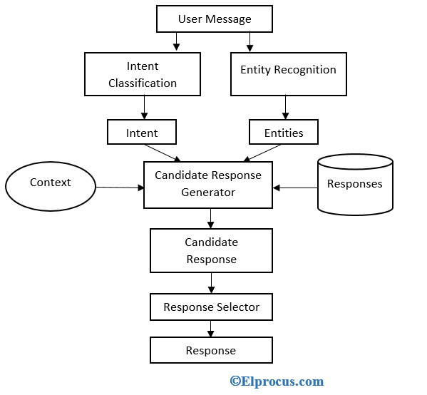

Figure 4.1 Architecture of Chat-bot for pregnant women

**4.2 DESCRIPTION**

In this project we are designing CHATBOT application which helps pregnant women’s to get answers for their  queries or doubt.To build this project we used NLP (natural language processing toolkit) and Machine Learning Algorithm called LSTM (Long Short Term Memory).LSTM will be trained with all possible questions and answers and whenever user ask any question then LSTM will predict answer for that question and handover that answer to chatbot to display to user.To train LSTM we have used some questions and answers related to pregnancy as no public dataset available so we gather some questions and answers from internet and all this questions are saved in dataset.

CHATBOT FOR PREGNANT WOMEN

CMRTC 10

**4.3 USE CASE DIAGRAM**

A use case diagram is a graphical depiction of a user's possible interactions with a system. A use case diagram shows various use cases and different types of users the system has. The use cases are represented by either circles or ellipses. The actors are often shown as stick figures.

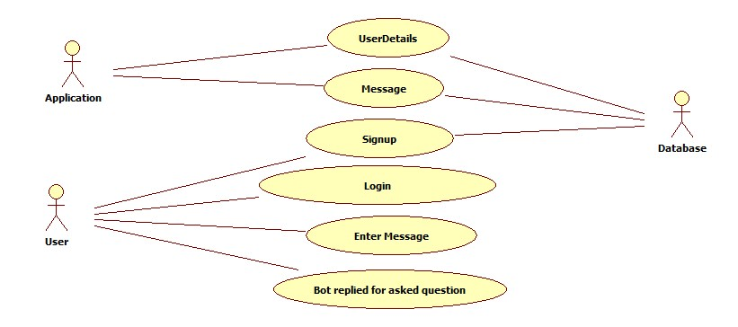

Figure 4.2 Use Case Diagram for Chat-bot for pregnant women

CHATBOT FOR PREGNANT WOMEN

CMRTC 11

**4.4 CLASS DIAGRAM**

Class diagram is a type of static structure diagram that describes the structure of a system by showing the system’s classes, their attributes, operations(or methods), and the relationships among objects.

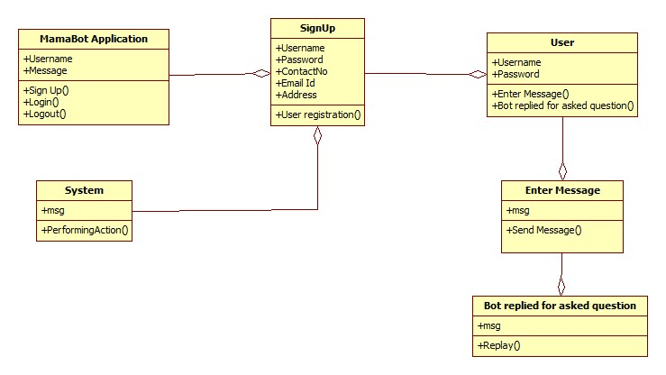

Figure 4.3 Class Diagram for Chat-bot for pregnant women

CHATBOT FOR PREGNANT WOMEN

CMRTC 12

**4.5 SEQUENCE DIAGRAM**

A sequence diagram shows object interactions arranged in time sequence. It depicts the objects involved in the scenario and the sequence of messages exchanged between the objects needed to carry out the functionality of the scenario. Sequence diagrams are typically associated with use case realizations in the logical view of the system under development.

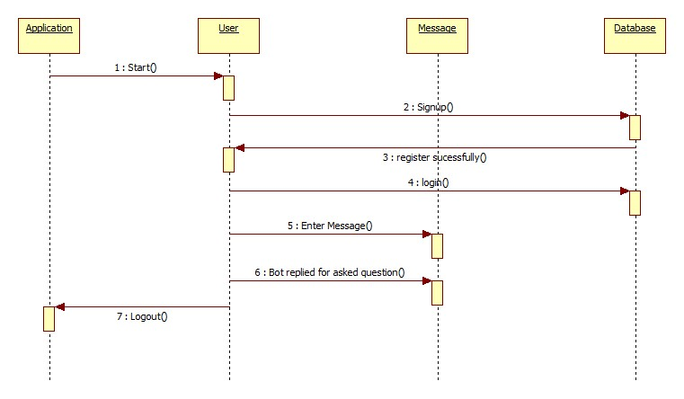

Figure 4.4 Sequence Diagram for Chat-bot for pregnant women

CHATBOT FOR PREGNANT WOMEN

CMRTC 13

**4.6 ACTIVITY DIAGRAM**

Activity diagrams are graphical representations of work flows of stepwise activities and actions with support for choice, iteration and concurrency. They can also include elements showing the flow of data between activities through one or more data stores.

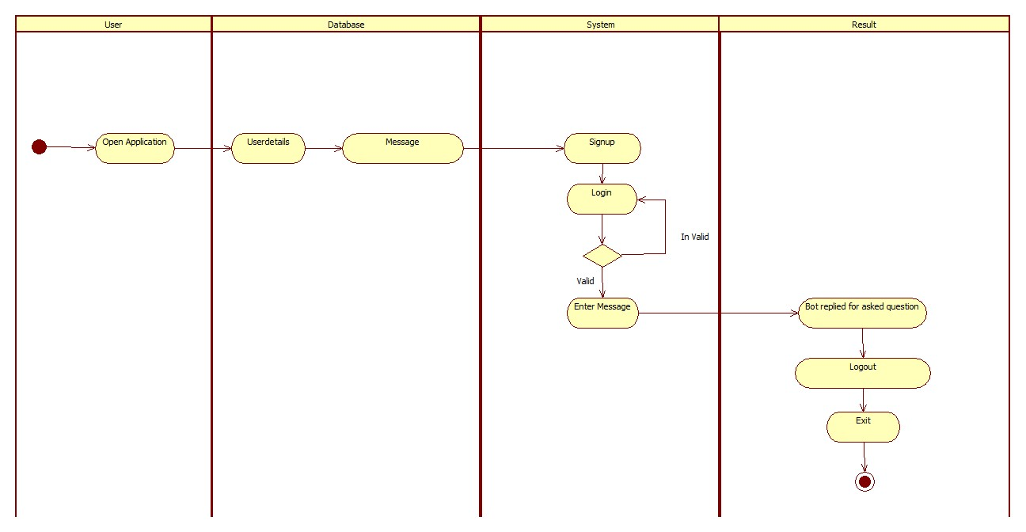

Figure 4.5 Activity Diagram for Chat-bot for pregnant women

CHATBOT FOR PREGNANT WOMEN

1. **IMPEMENTATION**

CMRTC 14

CHATBOT FOR PREGNANT WOMEN

* 1. **SAMPLE CODE**

my=open('/content/FinaldataV1.json','r')

jsondata=my.read()

intents=json.loads(jsondata)

print(intents)

import json

import numpy as np

import nltk

# nltk.download('punkt')

from nltk.stem.porter import PorterStemmer

import torch

import torch.nn as nn

from torch.utils.data import Dataset,DataLoader

my=open('/content/FinaldataV1.json','r')

jsondata=my.read()

intents=json.loads(jsondata)

stemmer = PorterStemmer()

def tokenize(sentence):

"""

split sentence into array of words/tokens

a token can be a word or punctuation character, or number

"""

return nltk.word\_tokenize(sentence)

def stem(word):

"""

stemming = find the root form of the word

examples:

words = ["organize", "organizes", "organizing"]

words = [stem(w) for w in words]

-> ["organ", "organ", "organ"]

"""

**14**

CMRTC 15

CHATBOT FOR PREGNANT WOMEN

return stemmer.stem(word.lower())

def bag\_of\_words(tokenized\_sentence, words):

"""

return bag of words array:

1 for each known word that exists in the sentence, 0 otherwise

example:

sentence = ["hello", "how", "are", "you"]

words = ["hi", "hello", "I", "you", "bye", "thank", "cool"]

bog = [ 0 , 1 , 0 , 1 , 0 , 0 , 0]

"""

# stem each word

sentence\_words = [stem(word) for word in tokenized\_sentence]

# initialize bag with 0 for each word

bag = np.zeros(len(words), dtype=np.float32)

for idx, w in enumerate(words):

if w in sentence\_words:

bag[idx] = 1

return bag

all\_words = []

tags = []

xy = []

for intent in intents['intents']:

tag = intent['tag']

# add to tag list

tags.append(tag)

for pattern in intent['patterns']:

# tokenize each word in the sentence

w = tokenize(pattern)

# add to our words list

all\_words.extend(w)

# add to xy pair

xy.append((w, tag))

CMRTC 16

CHATBOT FOR PREGNANT WOMEN

# stem and lower each word

ignore\_words = ['?', '.', '!']

all\_words = [stem(w) for w in all\_words if w not in ignore\_words]

# remove duplicates and sort

all\_words = sorted(set(all\_words))

tags = sorted(set(tags))

print(len(xy), "patterns")

print(len(tags), "tags:", tags)

print(len(all\_words), "unique stemmed words:", all\_words)

# create training data

X\_train = []

y\_train = []

for (pattern\_sentence, tag) in xy:

# X: bag of words for each pattern\_sentence

bag = bag\_of\_words(pattern\_sentence, all\_words)

X\_train.append(bag)

# y: PyTorch CrossEntropyLoss needs only class labels, not one-hot

label = tags.index(tag)

y\_train.append(label)

X\_train = np.array(X\_train)

y\_train = np.array(y\_train)

num\_epochs = 1000

batch\_size = 8

learning\_rate = 0.001

input\_size = len(X\_train[0])

hidden\_size = 8

output\_size = len(tags)

print(input\_size, output\_size)

class ChatDataset(Dataset):

def \_\_init\_\_(self):

self.n\_samples = len(X\_train)

self.x\_data = X\_train

self.y\_data = y\_train

CHATBOT FOR PREGNANT WOMEN

def \_\_getitem\_\_(self, index):

return self.x\_data[index], self.y\_data[index]

# we can call len(dataset) to return the size

def \_\_len\_\_(self):

return self.n\_samples

dataset = ChatDataset()

train\_loader = DataLoader(dataset=dataset,

batch\_size=batch\_size,

shuffle=True,

num\_workers=0)

device = torch.device('cuda' if torch.cuda.is\_available() else 'cpu')

model = NeuralNet(input\_size, hidden\_size, output\_size).to(device)

criterion = nn.CrossEntropyLoss()

optimizer = torch.optim.Adam(model.parameters(), lr=learning\_rate)

# Train the model

for epoch in range(num\_epochs):

for (words, labels) in train\_loader:

words = words.to(device)

labels = labels.to(dtype=torch.long).to(device)

# Forward pass

outputs = model(words)

# labels = torch.max(labels, 1)[1]

loss = criterion(outputs, labels)

optimizer.zero\_grad()

loss.backward()

optimizer.step()

**17**

CMRTC 17

CHATBOT FOR PREGNANT WOMEN

if (epoch+1) % 100 == 0:

print (f'Epoch [{epoch+1}/{num\_epochs}], Loss: {loss.item():.4f}')

print(f'final loss: {loss.item():.4f}')

data = {

"model\_state": model.state\_dict(),

"input\_size": input\_size,

"hidden\_size": hidden\_size,

"output\_size": output\_size,

"all\_words": all\_words,

"tags": tags

}

FILE = "s.pth"

torch.save(data, FILE)

print(f'training complete. file saved to {FILE}')

import torch

import torch.nn as nn

class NeuralNet(nn.Module):

def \_\_init\_\_(self, input\_size, hidden\_size, num\_classes):

super(NeuralNet, self).\_\_init\_\_()

self.l1 = nn.Linear(input\_size, hidden\_size)

self.l2 = nn.Linear(hidden\_size, hidden\_size)

self.l3 = nn.Linear(hidden\_size, num\_classes)

self.relu = nn.ReLU()

def forward(self, x):

out = self.l1(x)

out = self.relu(out)

out = self.l2(out)

out = self.relu(out)

out = self.l3(out)

# no activation and no softmax at the end

return out

CMRTC 18

CHATBOT FOR PREGNANT WOMEN

import random

import json

FILE = "s.pth"

data = torch.load(FILE)

input\_size = data["input\_size"]

hidden\_size = data["hidden\_size"]

output\_size = data["output\_size"]

all\_words = data['all\_words']

tags = data['tags']

model\_state = data["model\_state"]

model = NeuralNet(input\_size, hidden\_size, output\_size).to(device)

model.load\_state\_dict(model\_state)

model.eval()

bot\_name = "ChatBOT: "

print("Hello! Let's chat! (type 'quit' to exit)")

while True:

# sentence = "do you use credit cards?"

sentence = input("You: ")

if sentence == "Thankyou":

break

sentence = tokenize(sentence)

X = bag\_of\_words(sentence, all\_words)

X = X.reshape(1, X.shape[0])

X = torch.from\_numpy(X).to(device)

output = model(X)

\_, predicted = torch.max(output, dim=1)

CMRTC 19

CHATBOT FOR PREGNANT WOMEN

tag = tags[predicted.item()]

probs = torch.softmax(output, dim=1)

prob = probs[0][predicted.item()]

if prob.item() > 0.75:

for intent in intents['intents']:

if tag == intent["tag"]:

reply=random.choice(intent['responses'])

print(f"{bot\_name}",reply)

else:

print(f"{bot\_name}: I do not understand...")

1. **RESULTS**

**6. RESULTS**

CMRTC 20

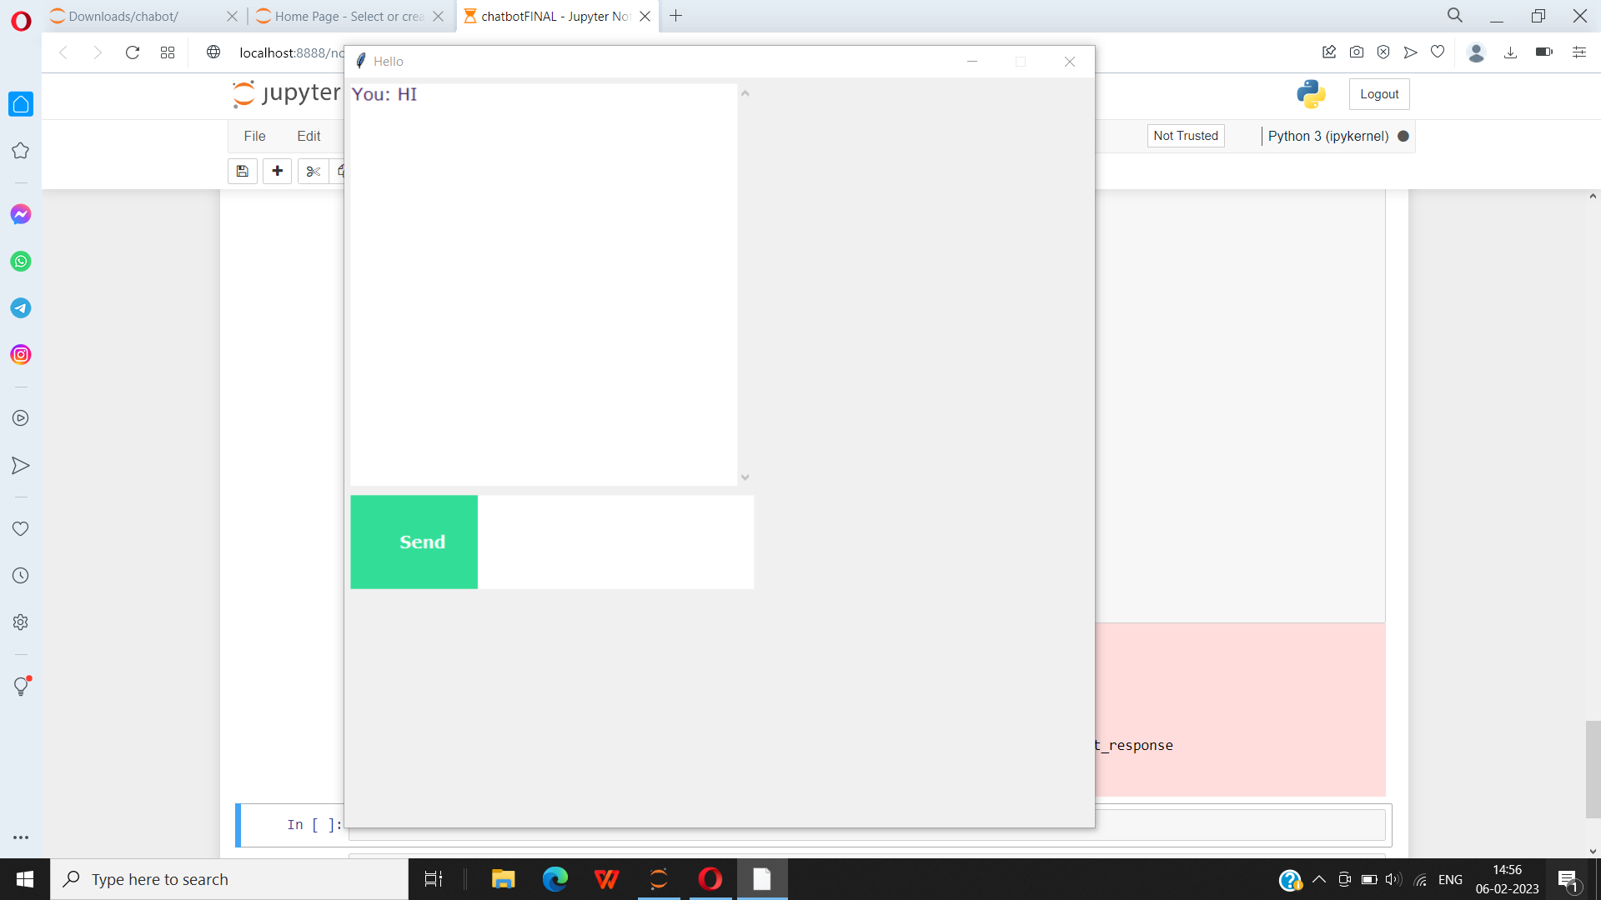

Screenshot 6.1 Final GUI of ChatBot for Pregnant Women

CHATBOT FOR PREGNANT WOMEN

CMRTC 21

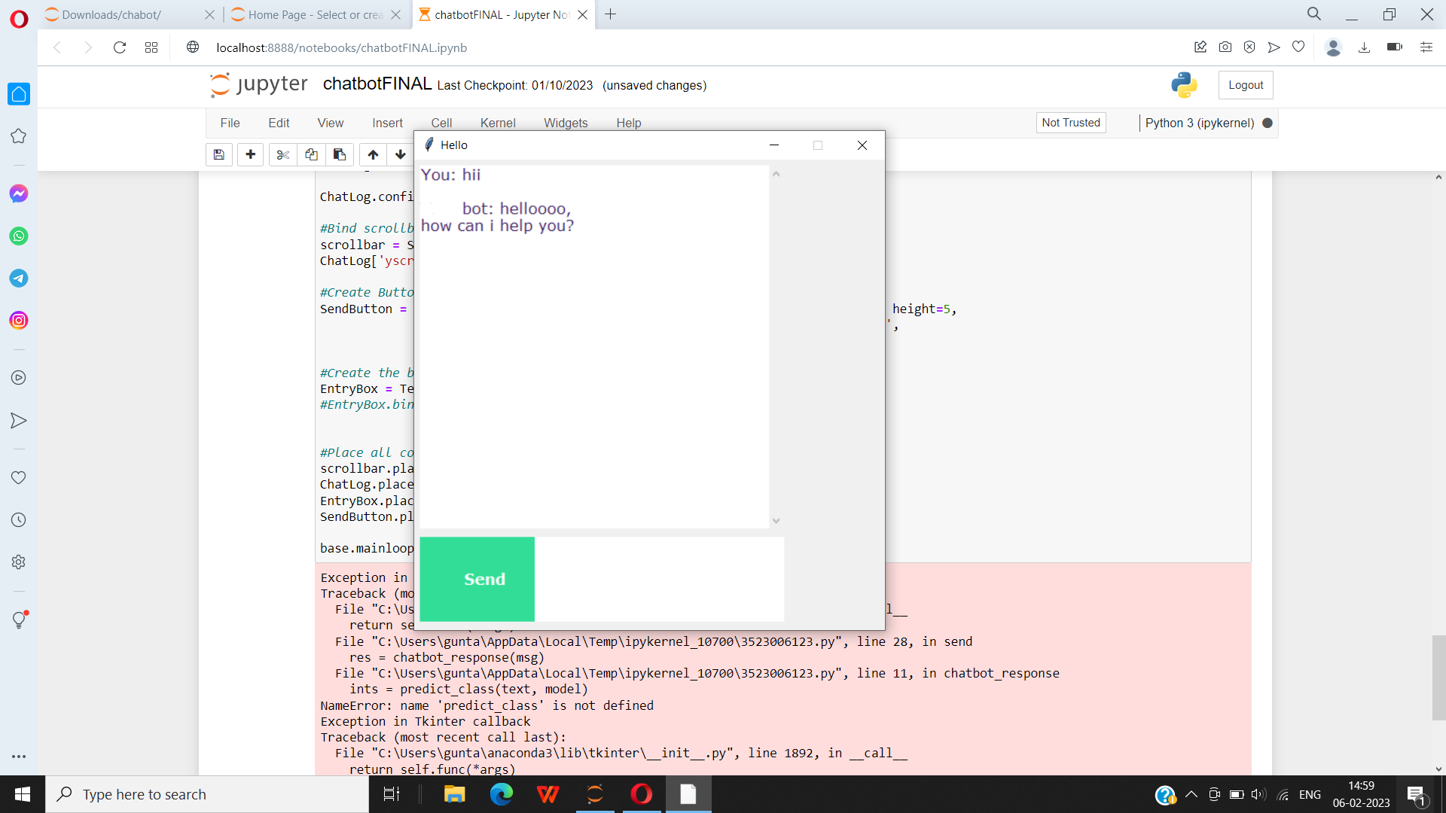

Screenshot 6.2 Conversation of ChatBot with Pregnant Women

PREDICTION OF HEART DISEASE

PREDICTION OF HEART DISEASE

CHATBOT FOR PREGNANT WOMEN

1. **TESTING**

CMRTC 22

CHATBOT FOR PREGNANT WOMEN

**7.TESTING**

**7.1 INTRODUCTION TO TESTING**

The purpose of testing is to discover errors. Testing is the process of trying to discover every conceivable fault or weakness in a work product. It provides a way to check the functionality of components, subassemblies, assemblies and/or a finished product. It is the process of exercising software with the intent of ensuring that the Software system meets its requirements and user expectations and does not fail in an unacceptable manner. There are various types of tests. Each test type addresses a specific testing requirement.

**7.2 TYPES OF TESTING**

**7.2.1 UNIT TESTING**

Unit testing involves the design of test cases that validate that the internal program logic is functioning properly, and that program inputs produce valid outputs. All decision branches and internal code flow should be validated. It is the testing of individual software units of the application .It is done after the completion of an individual unit before integration. This is a structural testing that relies on knowledge of its construction and is invasive. Unit tests perform basic tests at component level and test a specific business process, application and/or system configuration. Unit tests ensure that each unique path of a business process performs accurately to the documented specifications and contains clearly defined inputs and expected results.

CMRTC 23

CHATBOT FOR PREGNANT WOMEN

**7.2.2 INTEGRATION TESTING**

Integration tests are designed to test integrated software components to determine if they actually run as one program. Integration tests demonstrate that although the components were individually satisfactory, as shown by successfully unit testing, the combination of components is correct and consistent. Integration testing is specifically aimed at exposing the problems that arise from the combination of components.

**7.2.3 FUNCTIONAL TESTING**

Functional tests provide systematic demonstrations that functions tested are available as specified by the business and technical requirements, system

documentation, and user manuals. Functional testing is centered on the following items:

Valid Input : identified classes of valid input must be accepted.

Invalid : identified classes of invalid input must

Input be rejected.

Functions :. identified functions must be exercised.

Output : identified classes of application outputs

must be exercised

Systems/Procedures: interfacing systems or procedures must be invoked. Organization and preparation of functional tests is focused on requirements, key functions, or special test cases.

CMRTC 24

**7.3 TEST CASES**

**7.3.1 CLASSIFICATION**

|  |  |  |  |  |
| --- | --- | --- | --- | --- |
| Test case ID | Test case name | Purpose | Input | Output |
| 1. | Answer prediction | To clarify the doubts of a pregnant woman | Queries of pregnant women or their families | The output is the answer to the question asked by pregnant women |

CHATBOT FOR PREGNANT WOMEN

1. **CONCLUSION**

CMRTC 25

CHATBOT FOR PREGNANT WOMEN

**8.CONCLUSION & FUTURE SCOPE**

**8.1 PROJECT CONCLUSION**

Healthcare is one of the top three biggest mobile trends in US. In recent study shows that US adults who own smartphone or other wireless device, have at least one health/fitness app on their smartphone (+16% over the past two years) and, generally, health Apps have some of the highest number of downloads. Two-thirds of women said they would use a mobile App to manage health-related issues . Similar trends are expected for Europe.

In this project we are designing CHATBOT application which helps pregnant women’s to get answers for their  queries or doubt.To build this project we used NLP (natural language processing toolkit) and Machine Learning Algorithm called LSTM (Long Short Term Memory).LSTM will be trained with all possible questions and answers and whenever user ask any question then LSTM will predict answer for that question and handover that answer to chatbot to display to user.To train LSTM we have used some questions and answers related to pregnancy as no public dataset available so we gather some questions and answers from internet and all this questions are saved in dataset.

**8.2 FUTURE SCOPE**

The main objective of our project is to serve wide audience across the globe, for which we would like to update the chabot by adding more language compatability to it. And the accuracy of out project is around 100 percent, but with time and advanced hardware we can try to further improve the dataset of our project. The datasets that are available to public are very old data and is very less, so we would like to further improve the training process by providing bigger datasets. With availability of advanced hardware, we can further reduce the time taken to predict the results. We also have plans to further improve the GUI( graphical user interface).

1. **BIBILIOGRAPHY**

CHATBOT FOR PREGNANT WOMEN

1. **BIBILIOGRAPHY**
   1. **REFERENCES**

1. Avalverde, D. (2019). A Brief History of Chatbots. Perception, Control, Cognition. Retrieved March 9, 2019
2. Colace, F., De Santo, M., Lombardi, M., Pascale, L., Pietrosanto, A. (2018). Chatbot for E-Learning: A Cases Study. International Journal of Mechanical Engineering and Robotics Research Vol. 7, No. 5, September.
3. [Nguyen](https://www.google.com/url?q=https://www.businessinsider.com/author/mai-hanh-nguyen&sa=D&sntz=1&usg=AOvVaw0u1T5Ilc4EosCDTg4b4z6i" \t "/private/var/folders/pg/6v0vkwc57n10jfzlq2ph6q5c0000gn/T/com.kingsoft.wpsoffice.mac.global/wps-pranav/x/_blank), M. (2017). How artificial intelligence & machine learning produced robots we can talk to. Business Insider. Retrieved March 9, 2019
   1. **GITHUB LINK**

**<https://github.com/ananyaj6/Major-Project/upload>**

**27**

**27**

CMRTC 26